“The Outsiders”
Poster Collage
Find images set in the same era as the novel, “The Outsiders”. You will find these pictures on the Internet—they will give you an idea of the cars, entertainment, sayings and lifestyle of the characters in the novel.
INSTRUCTIONS: “The Outsiders” is set in the mid 1960’s (not the hippie era or Woodstock). Find pictures of the following categories on Google Image. Be sure all your pictures reflect that time in history.
  - Slang they used
  - President in office
  - News worthy events
  - Cars
  - Restaurants
  - Movies
  - Price of items
  - Fashion
  - Music
  - Role models
  - Sports
  - Etc.

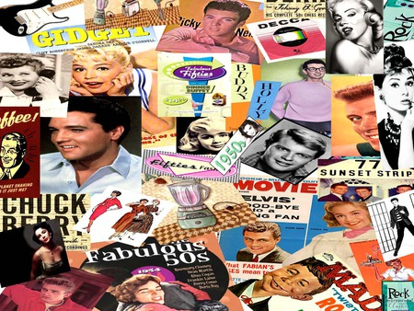
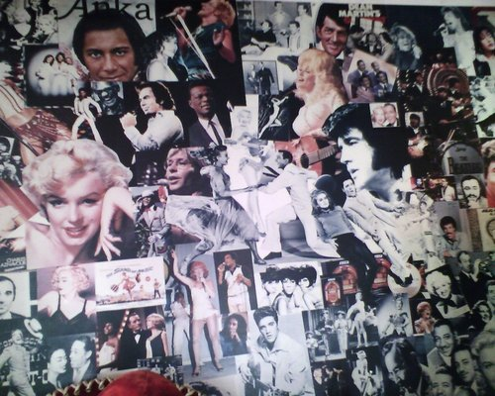
Make a poster collage by copying and pasting these pictures. Be artistic with the design and layout. Have fun!

