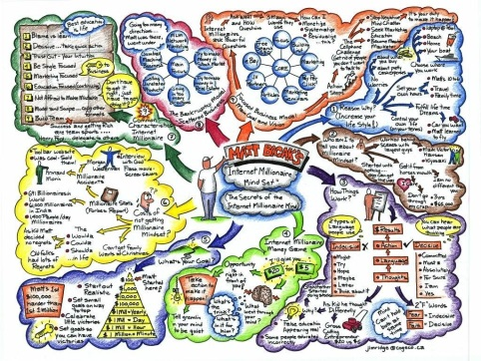
Mind Map

Definition of a Mind Map
- A mind map is a visual representation of information that includes a central idea surrounded by connected colour-coded branches of associated topics or information.
- Mind mapping is a visual form of note taking that offers an overview of a topic. Mind mapping helps you to comprehend, create new ideas and build connections.
- Through the use of colors, images and words, mind mapping encourages you to begin with a central idea and expand outward to more in-depth details.
Your Egghead Mind Map will include the Elements of Fiction
- Setting. It is the time and place when the story occurs. Setting sets the stage for action. Setting helps create the atmosphere and tone.

- Theme is the overall meaning that the author conveys through events and characters’ experiences.

- Point of View, the perspective the story is told from. Who tells the story and what is their point of view?

- Plot is the sequence of events in the story. Events build conflict. Each event changes or develops dynamic characters. Character interaction gives meaning to the story.

- Characters, people or personalities. Characters are described by the narrator and through their actions and dialogue. Who are the main characters and what are their traits.

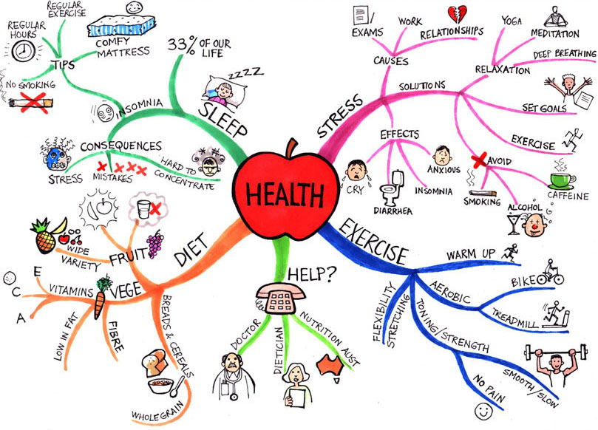
- Conflict is the struggle between the main character and an opposing force. Conflict can occur between characters and themselves, another character, nature or society (man vs. man, man vs. himself etc). What are the main conflicts in the story.

